Yelp Leads — Lead Routing & Automation Workflow

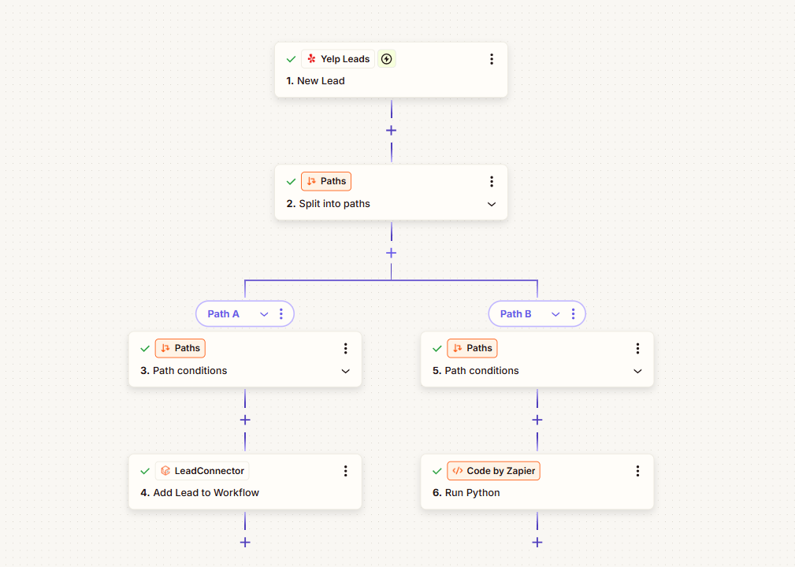

Project Description
An automated lead-routing workflow designed to take new leads from Yelp and determine how each one should be handled. The workflow uses conditional paths to separate leads based on defined criteria, sending them either into a LeadConnector workflow or through a Code by Zapier step for additional processing.
This creates a cleaner handoff between lead generation and the systems responsible for follow-up or further lead processing, without requiring the team to manually sort every incoming Yelp lead. Yelp supports a New Lead trigger in Zapier, while LeadConnector supports actions such as adding leads to existing workflows.

Automation Scope
- Yelp new-lead trigger
- Automated lead intake
- Conditional path routing
- Lead qualification and segmentation
- Path A routing logic
- Path B processing logic
- LeadConnector workflow handoff
- Code by Zapier processing
- Python-based data processing
- Downstream workflow assignment
- Automated lead management

Workflow
Yelp New Lead → Split Into Paths → Evaluate Path Conditions
Path A → LeadConnector → Add Lead to Workflow
Path B → Code by Zapier → Run Python
The workflow begins when a new Yelp lead is received and evaluates the available lead information against the defined path conditions. Leads matching Path A are passed into a LeadConnector workflow, while Path B sends the information through Code by Zapier for additional processing. Zapier Paths are designed to route data into different actions based on conditional rules.

Key Objective
Automate the handling of incoming Yelp leads by intelligently routing each lead to the right next step, reducing manual sorting and creating a more consistent process for follow-up, CRM workflows, and external lead processing.

